EX-2: Scheduling of project with PERT and CPM techniques to estimate the completion time. 2a) CPM

Aim:

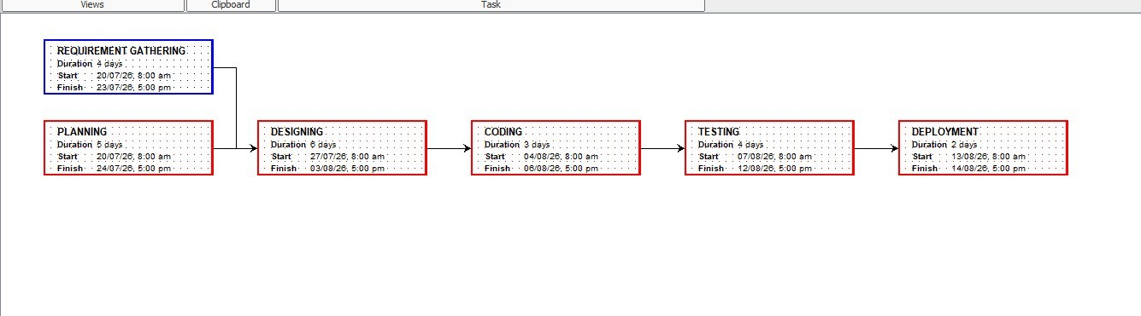
To create a project schedule using the Critical Path Method (CPM) in ProjectLibre by defining tasks, assigning resources, setting task dependencies, and generating the Gantt Chart and Network
Diagram.

Algorithm:
- Create a new project in ProjectLibre.
- Enter project tasks and their durations.
- Define predecessor relationships between tasks.
- Assign resources to each task.
- Generate the Gantt Chart and Network Diagram.
- Identify the critical path and save the project.

Procedure:
  - Open ProjectLibre and create a new project.
  - Add all project tasks with their durations.
  - Set task dependencies using the Predecessor field.
  - Create and assign resources to the tasks.
  - View the Gantt Chart and Network Diagram.
  - Identify the critical path and save the project.
OUTPUT:

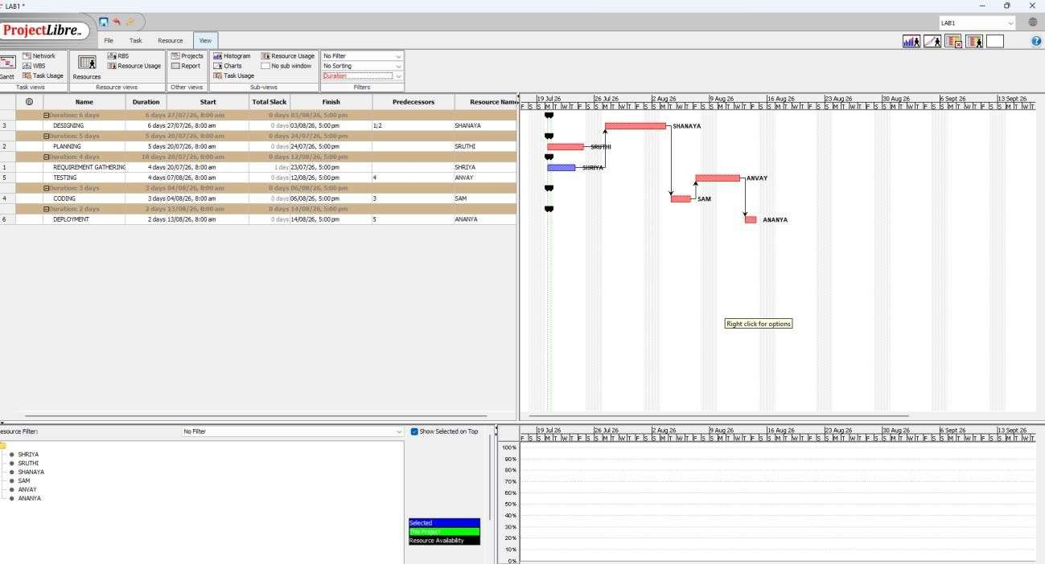

2b) PERT

Aim:
To analyze a project using the Program Evaluation and Review Technique (PERT) by estimating optimistic, most likely, and pessimistic activity durations, calculating the expected completion time, and determining the project schedule.

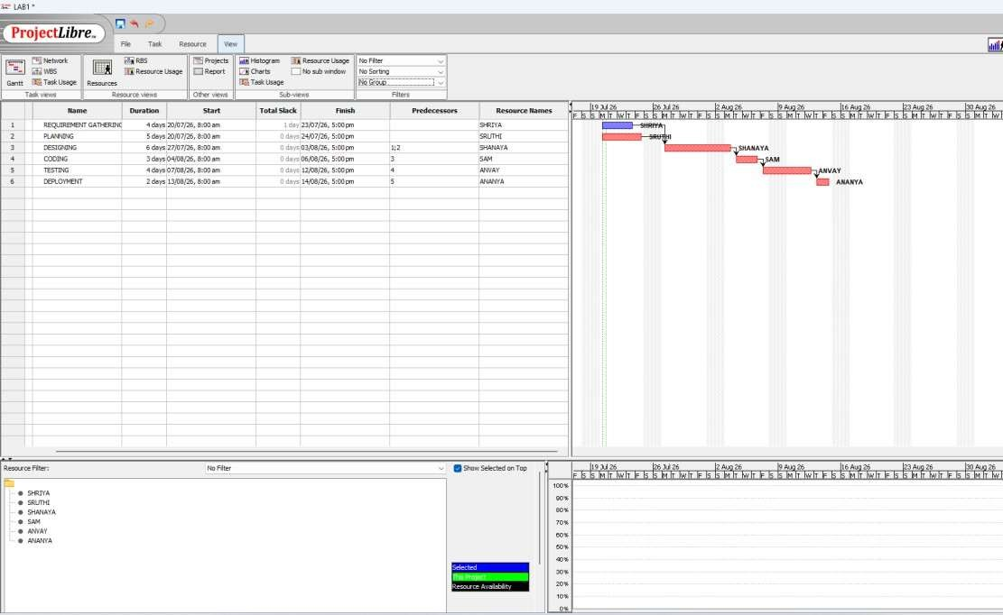
Algorithm:
- List all project activities.
- Estimate Optimistic (O), Most Likely (M), and Pessimistic (P) times for each activity.
- Calculate the expected time using TE=O+4M+P6TE=\frac{O+4M+P}{6}TE=6O+4M+P.
- Draw the PERT network with activity dependencies.
- Determine the critical path and estimate the project completion time.

Procedure:
  - Identify all project activities and their sequence.
  - Assign O, M, and P time estimates to each activity.
  - Calculate the expected time for every activity.
  - Draw the PERT network based on task dependencies.
  - Find the critical path and estimate the total project duration.
  - Record and analyze the results.

OUTPUT:



RESULT :
Successfully scheduled the project using PERT (Program Evaluation and Review Technique) and CPM (Critical Path Method) to estimate the project completion time, identify the critical path, and improve planning and resource management.

